**1.What is interactive and scripting mode programming in python?**

**Objective:**

* To see different mode of programming in python.

**Process:**

* Interactive mode programming.

Invoking the interpreter without passing a script file as a parameter.

* Scripting mode programming.

Invoking the interpreter without passing a script file as a parameter.

Python files have the extension .py. We should save the python file with .py extension.

**Input:**

* Simple addition code for both interactive and script mode programming.

**Output:**

* Addition of two numbers.

**Source code:**(Interactive mode programming)

#Type python3 on terminal

**$ python3**

Python 3.7.0 (default, Oct 9 2018, 10:31:47)

[GCC 7.3.0] :: Anaconda custom (64-bit) on linux

Type "help", "copyright", "credits" or "license" for more information.

# After getting >>>, we can type our codes

>>> a=5

>>> b=10

>>> c=a+b

>>> print(c)

15

**Source code:**(Script mode programming)

#First save the file with .py extension

#Second we should specify the path of file where its actually stored

#program code

a=5

b=10

c=a+b

print("The addition of a+b is:",c)

**Screen shot:**(Interactive mode programming)

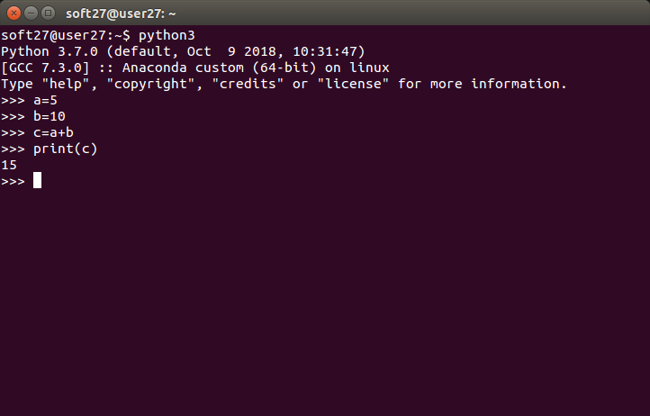

**Screen shot:**(Script mode programming)

